Project Name – Quiz Application System

Name – Gomathi Sambasivan

CWID – A20381083

**Phase 1 Final Project -**

**Quiz Application System**

**Application Description**

Th e quiz application system is a system where users can take test based on categorized topics and get their scores and status whether they have failed or passed the test. This system will comprise of two user roles viz admin and the test taker.

The admin will log in with his credentials and can perform the following activities -

Add/Delete a whole category of quiz.

Add/Delete Questionnaire sets with questions and answers.

Set duration, no. Of questions and passing criteria for the questionnaire.

Publish the whole questionnaire.

The test taker will have to first register and log in to the system. Ohter activities that he can perform are:

Take a test from any category.

Submit his/her test.

Get his/her score for the test and its status.

See his/her history of tests taken and their result in the dashboard.

**Entity Relationship Diagram (ERD) :**

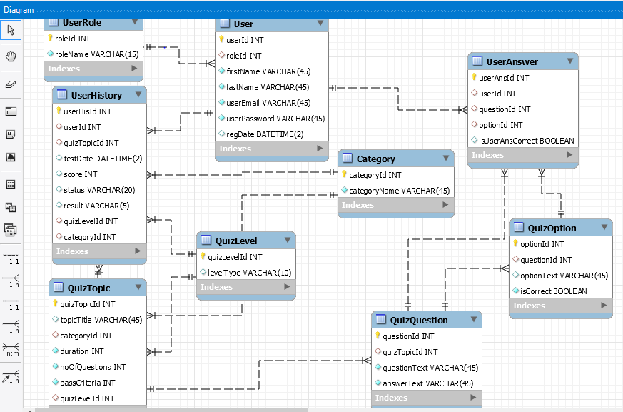

**Class Diagram :**

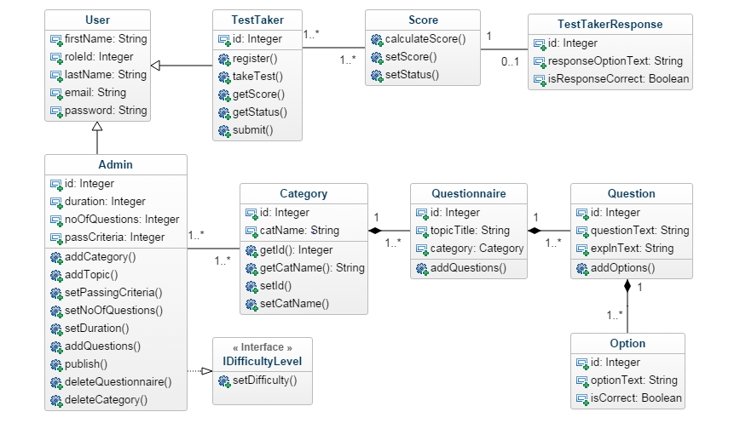**DDL Statements**

CREATE TABLE IF NOT EXISTS `QuizDbLocal`.`UserRole` (

`roleId` INT NOT NULL,

`roleName` VARCHAR(15) NOT NULL,

PRIMARY KEY (`roleId`))

ENGINE = InnoDB

CREATE TABLE IF NOT EXISTS `QuizDbLocal`.`User` (

`userId` INT NOT NULL AUTO_INCREMENT,

`roleId` INT NULL,

`firstName` VARCHAR(45) NOT NULL,

`lastName` VARCHAR(45) NOT NULL,

`userEmail` VARCHAR(45) NOT NULL,

`userPassword` VARCHAR(45) NOT NULL,

`regDate` DATETIME(2) NULL,

PRIMARY KEY (`userId`),

INDEX `roleId_idx` (`roleId` ASC),

CONSTRAINT `roleId`

FOREIGN KEY (`roleId`)

REFERENCES `QuizDbLocal`.`UserRole` (`roleId`)

ON DELETE CASCADE

ON UPDATE CASCADE)

ENGINE = InnoDB

CREATE TABLE IF NOT EXISTS `QuizDbLocal`.`QuizLevel` (

`quizLevelId` INT NOT NULL,

`levelType` VARCHAR(10) NULL,

PRIMARY KEY (`quizLevelId`))

ENGINE = InnoDB

CREATE TABLE IF NOT EXISTS `QuizDbLocal`.`Category` (

`categoryId` INT NOT NULL AUTO_INCREMENT,

`categoryName` VARCHAR(45) NOT NULL,

PRIMARY KEY (`categoryId`))

ENGINE = InnoDB

CREATE TABLE IF NOT EXISTS `QuizDbLocal`.`QuizTopic` (

`quizTopicId` INT NOT NULL AUTO_INCREMENT,

`topicTitle` VARCHAR(45) NULL,

`categoryId` INT NULL,

`duration` INT ZEROFILL NOT NULL,

`noOfQuestions` INT ZEROFILL NOT NULL,

`passCriteria` INT ZEROFILL NOT NULL,

`quizLevelId` INT NULL,

PRIMARY KEY (`quizTopicId`),

INDEX `categoryId_idx` (`categoryId` ASC),

INDEX `quizLevelId_idx` (`quizLevelId` ASC),

CONSTRAINT `categoryId`

FOREIGN KEY (`categoryId`)

REFERENCES `QuizDbLocal`.`Category` (`categoryId`)

ON DELETE CASCADE

ON UPDATE CASCADE,

CONSTRAINT `quizLevelId`

FOREIGN KEY (`quizLevelId`)

REFERENCES `QuizDbLocal`.`QuizLevel` (`quizLevelId`)

ON DELETE NO ACTION

ON UPDATE NO ACTION)

ENGINE = InnoDB

CREATE TABLE IF NOT EXISTS `QuizDbLocal`.`QuizQuestion` (

`questionId` INT NOT NULL,

`quizTopicId` INT NULL,

`questionText` VARCHAR(45) NOT NULL,

`answerText` VARCHAR(45) NOT NULL,

PRIMARY KEY (`questionId`),

INDEX `quizTopicId_idx` (`quizTopicId` ASC),

CONSTRAINT `quizTopicId`

FOREIGN KEY (`quizTopicId`)

REFERENCES `QuizDbLocal`.`QuizTopic` (`quizTopicId`)

ON DELETE NO ACTION

ON UPDATE NO ACTION)

ENGINE = InnoDB

CREATE TABLE IF NOT EXISTS `QuizDbLocal`.`QuizOption` (

`optionId` INT NOT NULL,

`questionId` INT NULL,

`optionText` VARCHAR(45) NULL,

`isCorrect` TINYINT(1) NOT NULL,

PRIMARY KEY (`optionId`),

INDEX `questionId_idx` (`questionId` ASC),

CONSTRAINT `questionId`

FOREIGN KEY (`questionId`)

REFERENCES `QuizDbLocal`.`QuizQuestion` (`questionId`)

ON DELETE NO ACTION

ON UPDATE NO ACTION)

ENGINE = InnoDB

CREATE TABLE IF NOT EXISTS `QuizDbLocal`.`UserAnswer` (

`userAnsId` INT NOT NULL,

`userId` INT NULL,

`questionId` INT NULL,

`optionId` INT NULL,

`isUserAnsCorrect` TINYINT(1) NULL,

PRIMARY KEY (`userAnsId`),

INDEX `userId_idx` (`userId` ASC),

INDEX `questionId_idx` (`questionId` ASC),

INDEX `optionId_idx` (`optionId` ASC),

CONSTRAINT `userId`

FOREIGN KEY (`userId`)

REFERENCES `QuizDbLocal`.`User` (`userId`)

ON DELETE NO ACTION

ON UPDATE NO ACTION,

CONSTRAINT `questionId`

FOREIGN KEY (`questionId`)

REFERENCES `QuizDbLocal`.`QuizQuestion` (`questionId`)

ON DELETE NO ACTION

ON UPDATE NO ACTION,

CONSTRAINT `optionId`

FOREIGN KEY (`optionId`)

REFERENCES `QuizDbLocal`.`QuizOption` (`optionId`)

ON DELETE NO ACTION

ON UPDATE NO ACTION)

ENGINE = InnoDB

CREATE TABLE IF NOT EXISTS `QuizDbLocal`.`UserHistory` (

`userHisId` INT NOT NULL,

`userId` INT NULL,

`quizTopicId` INT NULL,

`testDate` DATETIME(2) NULL,

`score` INT NULL,

`status` VARCHAR(20) NULL,

`result` VARCHAR(5) NULL,

`quizLevelId` INT NULL,

`categoryId` INT NULL,

PRIMARY KEY (`userHisId`),

INDEX `userId_idx` (`userId` ASC),

INDEX `quizTopicId_idx` (`quizTopicId` ASC),

INDEX `categoryId_idx` (`categoryId` ASC),

INDEX `quizLevelId_idx` (`quizLevelId` ASC),

CONSTRAINT `quizTopicId`

FOREIGN KEY (`quizTopicId`)

REFERENCES `QuizDbLocal`.`QuizTopic` (`quizTopicId`)

ON DELETE NO ACTION

ON UPDATE NO ACTION,

CONSTRAINT `userId`

FOREIGN KEY (`userId`)

REFERENCES `QuizDbLocal`.`User` (`userId`)

ON DELETE NO ACTION

ON UPDATE NO ACTION,

CONSTRAINT `categoryId`

FOREIGN KEY (`categoryId`)

REFERENCES `QuizDbLocal`.`Category` (`categoryId`)

ON DELETE NO ACTION

ON UPDATE NO ACTION,

CONSTRAINT `quizLevelId`

FOREIGN KEY (`quizLevelId`)

REFERENCES `QuizDbLocal`.`QuizLevel` (`quizLevelId`)

ON DELETE NO ACTION

ON UPDATE NO ACTION)

ENGINE = InnoDB